i

Properties

of

Fiberglass

ii

Preface

Fiberglass is a [fiber reinforced polymer](http://en.wikipedia.org/wiki/Fiber_reinforced_plastic) made of [plastic](http://en.wikipedia.org/wiki/Plastic) reinforced by [glass fibers](http://en.wikipedia.org/wiki/Glass_fiber), commonly woven into a mat. The plastic may be a [thermosetting plastic](http://en.wikipedia.org/wiki/Thermosetting_plastic)- most often [epoxy](http://en.wikipedia.org/wiki/Epoxy), [polyester](http://en.wikipedia.org/wiki/Polyester)- or [vinyl ester](http://en.wikipedia.org/wiki/Vinylester) or a [thermoplastic](http://en.wikipedia.org/wiki/Thermoplastic). The glass fibers are made of various types of glass depending upon the fiberglass use. These glasses all contain silica or silicate, with varying amounts of oxides of calcium, magnesium, and sometimes boron. Boron-containing fibreglasses consume half the global production of [boron](http://en.wikipedia.org/wiki/Boron) minerals, and are the largest commercial consumer of the element.

Fiberglass is a strong lightweight material and is used for many products. Although it's not as strong and stiff as [carbon fiber](http://en.wikipedia.org/wiki/Carbon_fiber), it is less brittle, and its raw materials are much cheaper. Its bulk strength and weight are also better than many metals, and it can be more readily molded into complex shapes. Applications of fiberglass include, aircraft, boats, automobiles, bath tubs and enclosures, hot tubs, septic tanks, water tanks, roofing, pipes, cladding, [casts](http://en.wikipedia.org/wiki/Orthopedic_cast), surfboards, and external door skins.

Under this project we have tested most common properties of fiber glass over plastic.Effectivity of fiber glass over plastic will be contrasted during the experiment. More over new paths will be opened for many inventions regarding fiber glass afterwards. This will be the beginning of a new era for all inventors with the help of fiberglass.

iii

Acknowlegement

Under the Supervision of Dr. Ragal and Dr.Pradeepan this project came to a realistic. We would appreciate the greatest contribution of Ms.Kamika who was a shadow for us till the end of the project.

iv

Contributors

P. Maheshwaran (Leader)

Thilini Minthari

Niroshan

Unity is wealth

v

Contents

Future

Perspective

Comparison

Discussion

Conclusions

Results

Experimental

Procedure

Background Theory

Introduction

References

Introduction to Fiberglass

vi

***Introduction***

01

F

iberglass refers to a group of products made from individual glass

fibers combined into a variety of forms. Glass fibers can be divided

Into two major groups according to their geometry: continuous fibers

Used in yarns and textiles, and the discontinuous (short) fibers used as

bats, blankets, or boards for insulation and filtration.

Fiberglass can be formed into yarn much like wool or cotton, and woven into fabric which is sometimes used for draperies. Fiberglass textiles are commonly used as a reinforcement material for molded and laminated plastics. Fiberglass wool, a thick, fluffy material made from discontinuous fibers, is used for thermal insulation and sound absorption. It is commonly found in ship and submarine bulkheads and hulls; automobile engine compartments and body panel liners; in Furnaces and air conditioning units; acoustical wall and ceiling panels architectural partitions.

Fiberglass can be tailored for specific applications such as Type E (electrical), used as electrical insulation tape, textiles and reinforcement; Type C (chemical), which has superior acid resistance, and Type T, for thermal insulation. Though commercial use of glass fiber is relatively recent, artisans created glass strands for decorating goblets and vases during the Renaissance.

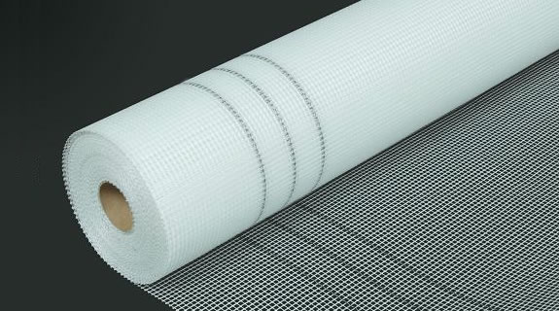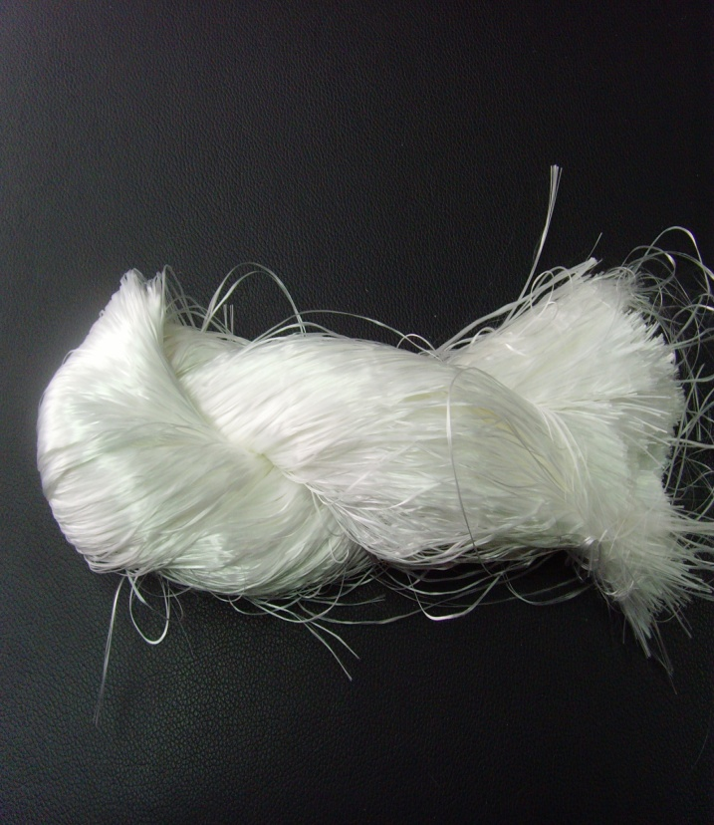

**Fiberglass row materials**

**Fiberglass row materials**

When Fiber was Introduced?

02

A French physicist, Rene-Antoine Ferchault de Reaumur, produced textiles decorated with fine glass strands in 1713, and British inventors duplicated the feat in 1822. A British silk weaver made a glass fabric in 1842, and another inventor, Edward Libbey, exhibited a dress woven of glass at the 1893 Columbian Exposition in Chicago. Glass wool, a fluffy mass of discontinuous fiber in random lengths, was first produced in Europe at the turn of the century, using a process that involved drawing fibers from rods horizontally to a revolving drum. Several decades later, a spinning process was developed and patented.

Glass fiber insulating material was manufactured in Germany during World War I .Research and development aimed at the industrial production of glass fibers progressed in the United States in the 1930s, under the direction of two major companies, the Owens-Illinois Glass Company and Corning Glass Works. These companies developed a fine, pliable, low-cost glass fiber by drawing molten glass through very fine orifices. In 1938, these two companies merged to form Owens-Corning Fiberglas Corp. Now simply known as Owens-Corning, it has become a $3-billion-a-year company, and is a leader in the fiberglass market.

**What are the Raw Materials that are used?**

03

The basic raw materials for fiberglass products are a variety of natural minerals and manufactured chemicals. The major ingredients are silica sand, limestone, and soda ash. Other ingredients may include calcined alumina, borax, feldspar,

nepheline syenite, magnesite, and kaolin clay, among others. Silica sand is used as the glass former, and soda ash and limestone help primarily to lower the melting temperature. Other ingredients are used to improve certain properties,such as borax for chemical resistance. Waste glass, also called cullet, is also used as a raw material. The raw materials must be carefully weighed in exact quantities and thoroughly mixed together (called batching) before being melted into glass.

**The Manufacturing Process**

04



***Melting***

Once the batch is prepared, it is fed into a furnace for melting. The furnace may be heated by electricity, fossil fuel, or a combination of the two. Temperature must be precisely controlled to maintain a smooth, steady flow of glass. The molten glass must be kept at a higher temperature (about 2500°F [1371°C]) than other types of glass in order to be formed into fiber. Once the glass becomes molten, it is transferred to the forming equipment via a channel(fore hearth) located at the end of the furnace.

***Forming into fibers***

05

Several different processes are used to form fibers, depending on the type of fiber. Textile fibers may be formed from molten glass directly from the furnace, or the molten glass may be fed first to a machine that forms glass marbles of about 0.62 inch (1.6 cm) in diameter. These marbles allow the glass to be inspected visually for impurities. In both the direct melt and marble melt process, the glass or glass marbles are fed through electrically heated bushings (also called spinnerets). The bushing is made of platinum or metal alloy, with anywhere from 200 to 3,000 very fine orifices. The molten glass passes through the orifices and comes out as fine filaments.

***Continuous-filament process***

A long, continuous fiber can be produced through the continuous-filament process. After the glass flows through the holes in the bushing, multiple strands are caught up on a high-speed winder. The winder revolves at about 2

miles (3 km) a minute, much faster than the rate of flow from the bushings. The tension pulls out the filaments while still molten, forming strands a fraction of the diameter of the openings in the bushing. A chemical binder is applied, which helps keep the fiber from breaking during later processing. The filament is then wound onto tubes. It can now be twisted and plied into yarn.

***Staple-fiber process***

An alternative method is the staple fiber process. As the molten glass flows through the bushings, jets of air rapidly cool the filaments. The turbulent bursts of air also break the filaments into lengths of 8-15 inches (20-38 cm). These filaments fall through a spray of lubricant onto a revolving drum, where they form a thin web. The web is drawn from the drum and pulled into a continuous strand of loosely assembled fibers. This strand can be processed into yarn by the same processes used for wool and cotton.

06

***Chopped fiber***

Instead of being formed into yarn, the continuous or long-staple strand may be chopped into short lengths. The strand is mounted on a set of bobbins, called a creel, and pulled through a machine which chops it into short pieces.

The chopped fiber is formed into mats to which a binder is added. After curing in an oven, the mat is rolled up.Various weights and thicknesses give products for shingles, built-up roofing, or decorative mats.

***Glass Wool***

The rotary or spinner process is used to make glass wool. In this process, molten glass from the furnace flows into a cylindrical container having small holes. As the container spins rapidly, horizontal streams of glass flow out of the

holes.The molten glass streams are converted into fibers by a downward blast of air, hot gas, or both. The fibers fall onto a conveyor belt, where they interlace with each other in a fleecy mass. This can be used for insulation, or the wool can be sprayed with a binder, compressed into the desired thickness, and cured in an oven. The heat sets the binder, and the resulting product may be a rigid or semi-rigid board, or a flexible bat.

***Protective coatings***

In addition to binders, other coatings are required for fiberglass products. Lubricants are used to reduce fiber abrasion and are either directly sprayed on the fiber or added into the binder. An anti-static composition is also sometimes sprayed onto the surface of fiberglass insulation mats during the cooling step. Cooling air drawn through the mat causes the anti-static agent to penetrate the entire thickness of the mat. The anti-static agent consists of two ingredients—a material that minimizes the generation of static electricity, and a material that serves as a corrosion inhibitor and stabilizer.Sizing is any coating applied to textile fibers in the forming operation, and may contain one or more components (lubricants, binders, or coupling agents). Coupling agents are used on strands that will be used for reinforcing plastics, to strengthen the bond to the reinforced material. Sometimes a finishing operation is required to remove these coatings, or to add another coating. For plastic reinforcements, sizing may be removed with heat or chemicals and a coupling agent applied. For decorative applications, fabrics must be heat treated to remove sizing and to set the weave. Dye base coatings are then applied before dying or printing.

07

**Quality Control**

During the production of fiberglass insulation, material is sampled at a number of locations in the process to maintain quality. These locations include: the mixed batch being fed to the electric melter, molten glass from the bushing which feeds the fiberizer; glass fiber coming out of the fiberizer machine; and final cured product emerging from the end of the Does yourproduction line. The bulk glass and fiber samples are analyzed for chemical composition and the presence of flaws using sophisticated chemical analyzers and microscopes. Particle size distribution of the batch material is obtained by passing the material through a number of different sized sieves. The final product is measured for thickness after packaging according to specifications. A change in thickness indicates that glass quality is below the standard. Fiberglass insulation manufacturers also use a variety of standardized test procedures to measure, adjust, and optimize product acoustical resistance, sound absorption, and sound barrier performance. The acoustical properties can be controlled by adjusting such production variables as fiber diameter, bulk density, thickness, and binder content. A similar approach is used to control thermal properties.

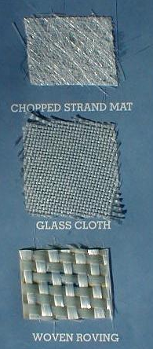





09

How Fiber has made?

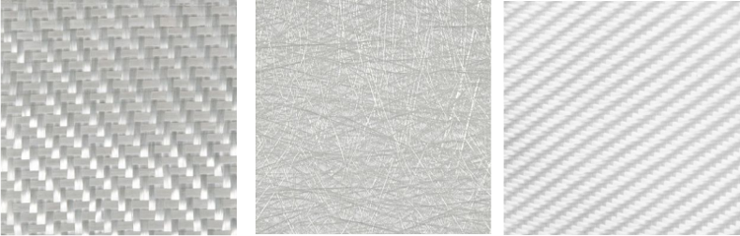

Fiberglass is made primarily of silica (silicon dioxide, SiO2) but contains some percentage of other oxides that modify its properties for a particular application. Common fiberglass modifiers are calcium oxide (CaO), magnesium oxide (MgO), aluminum oxide (Al2O3) and boric oxide (B2O3). The chemical formula depends on the ratios of the different compounds used.

SiO2 Silicondioxide

CaO Calsiumoxide

MgO Magnisiumoxide

Al2O3 Aluminiumoxide

B2O3 Boricoxide

Fiber Glass

# Characteristics of Fiber

09

Fiberglass has some characteristics that make it desirable in many applications. Fiberglass is non-conductive (i.e. an insulator) and it is generally invisible to most types of transmissions. This makes it a good choice when dealing with electrical or broadcast applications.

There are five major types of fiberglass

E-glass and S-glass are, by far, the most common types found in composites. These types have good combinations of chemical resistance, mechanical properties and insulating properties. Of the two, E-glass offers the more attractive economics, and S-glass offers better mechanical performance.

Plastic Vs Fiberglass

10

|  |  |  |
| --- | --- | --- |
| Characteristic | Fiberglass | Plastic |
| Strength | Fiberglass will maintain up to 25 times the strength of steel per pound, giving it a very impressive strength-to-weight ratio. | Plastic serves as an alternative for wood and metal, though it does not compete with the strength of fiberglass. |
| Weight | Fiberglass is an excellent and lighter substitute for metal, or wood storage cabinets. | Although slightly lighter in weight, plastic enclosures are much less durable than Fiberglass safety equipment cabinets |
| Durability | The inherent strength of Fiberglass gives it exceptional durability in highly corrosive environments. It will also withstand heat, salt, and a wide array of chemicals, including chlorine and most acids. | Plastic will not tolerate extreme environments or chemicals, leaving your personal protection equipment exposed to the elements. |
| Appearance | One of the most obvious differences between fiberglass and other cabinet types is the appearance. Fiberglass cabinets have sleek contours and superior molded appearance with high visibility colors. | In many cases, storage cabinets constructed of plastic do not have the smooth lines common to Fiberglass cabinets. The superior appearance of fiberglass products allows them to be used in just about any setting. |
| Conductivity | Fiberglass is non-conductive RF transparent and acts as an insulator against electromagnetic fields, making it the best choice for electrical and electronic equipment storage. | Plastic is less of an electrical insulator than fiberglass and, because of its limited durability, plastic will not protect highly sensitive electronic equipment as consistently as fiberglass. |
| Corrosion | Fiberglass is highly resistant to corrosion caused by a multitude of environmental elements including salt air, chemicals, acids, and chlorine, making it the preferred choice over plastic. | 11  Plastic storage cabinets have a short lifespan when used in highly corrosive environments potentially exposing their contents to the harsh elements and thereby compromising their reliability. |
| Finish | Plastic storage cabinets have a short lifespan when used in highly corrosive environments potentially exposing their contents to the harsh elements and thereby compromising their reliability. | Plastic colors do not hold up over time, especially in environments where they are exposed to salt air. |
| Acoustic Properties | Fiberglass provides superior acoustical properties when compared to plastic or metal. Various type of sound deadening materials can be laminated between high strength layers of Fiberglass matte to achieve the preferred level of sound deadening. | Plastic does not offer the same type of sound dampening or the ability to have laminated layers |
| Stability | Fiberglass exhibits the least amount of expansion and/or contraction when compared to plastic, wood, or metal utility cabinets. Fiberglass parts have excellent dimensional stability and will hold their shapes under severe mechanical and environmental stresses. Fiberglass provides protection against UV rays, extreme temperatures, salt and a variety of chemicals including many acids. | Though durable for less extreme conditions, plastic will not hold shape under extreme environmental stresses. UV light causes degradation of plastic, rendering it brittle and vulnerable to cracking. In addition, gas and oil can affect the integrity of a plastic storage unit. |

Applications of Fiberglass

12

Sculpture

Swimming pools

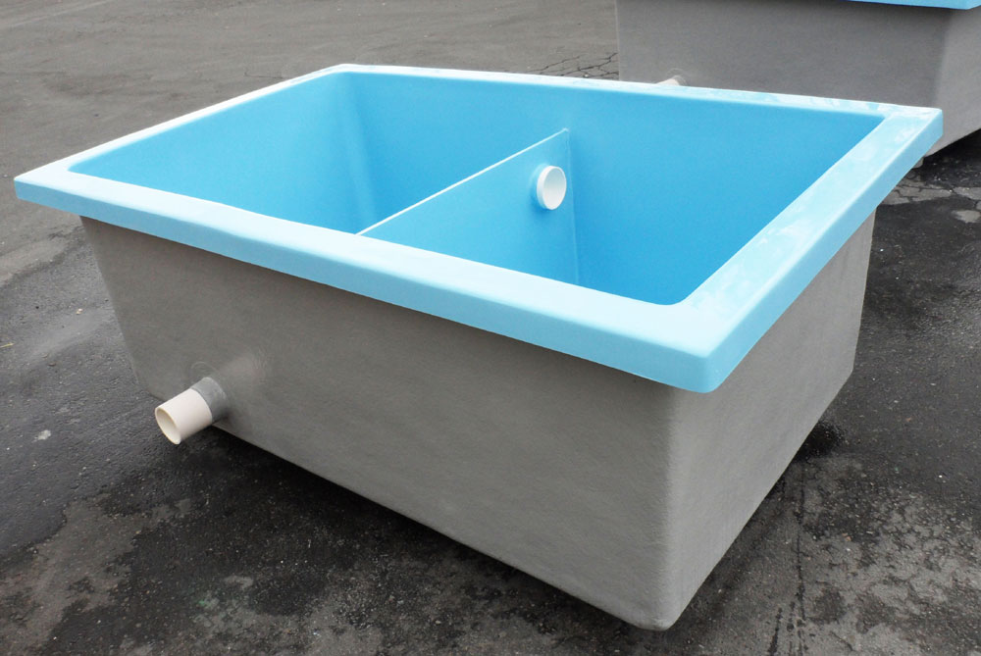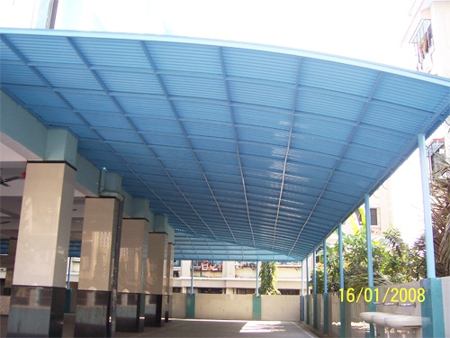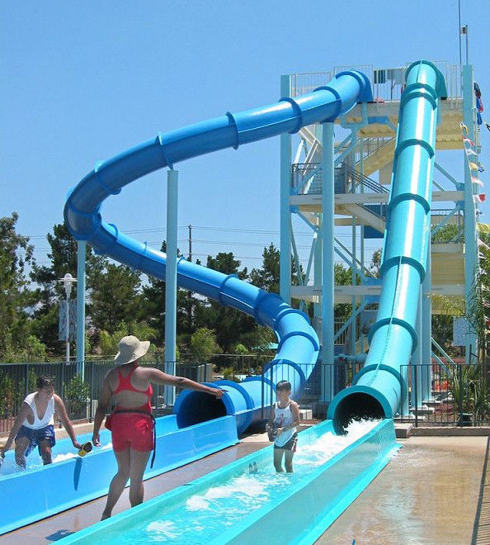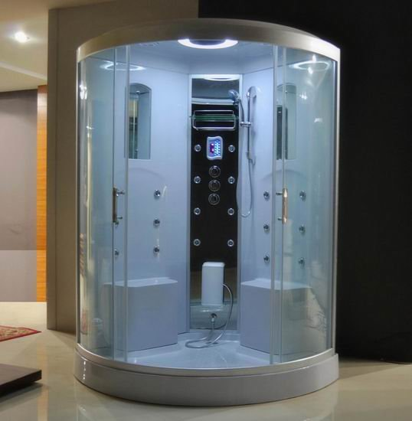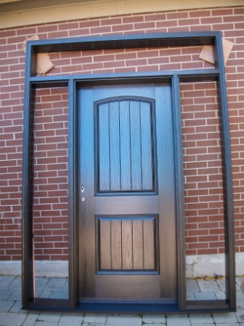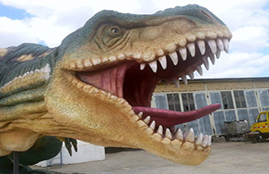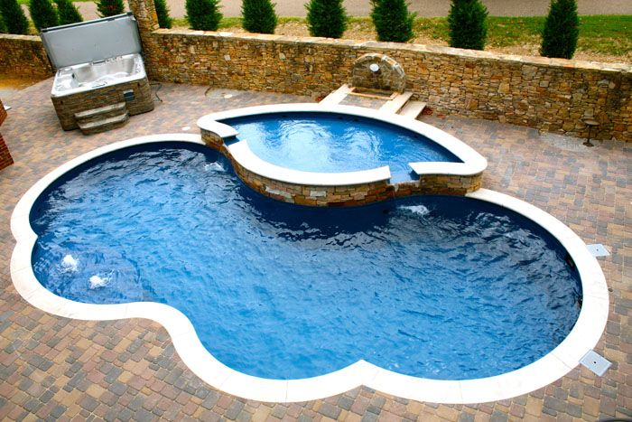

Architecture

Watert Tanks

Roof tops

Kiddy world

Bathroom kit

Doors

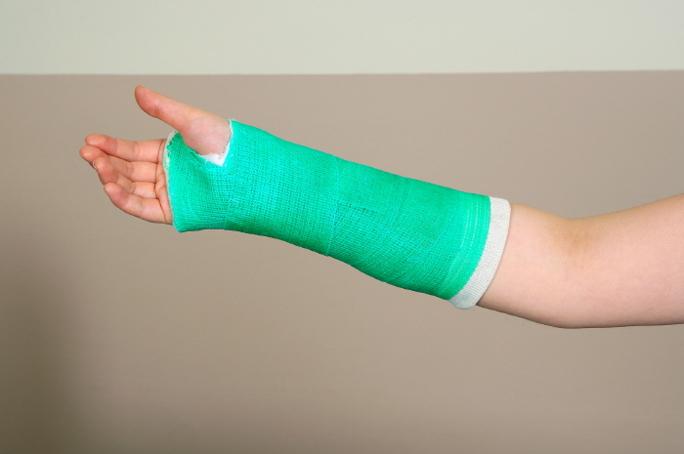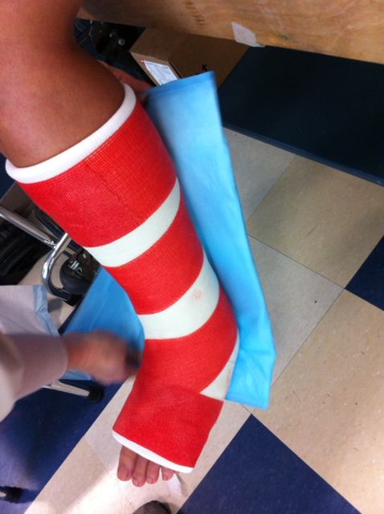

Health and Care

13

Casting

Casting

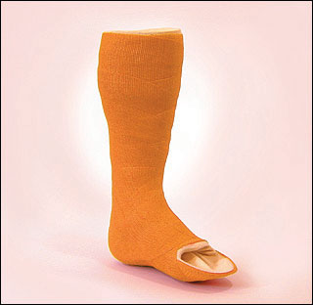

Casting

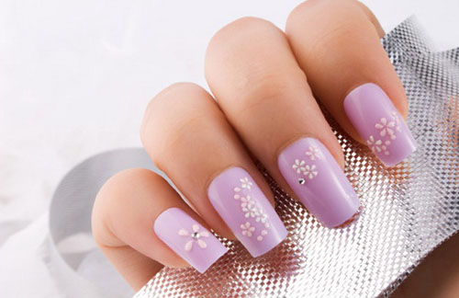

Beauty

Fake Nails

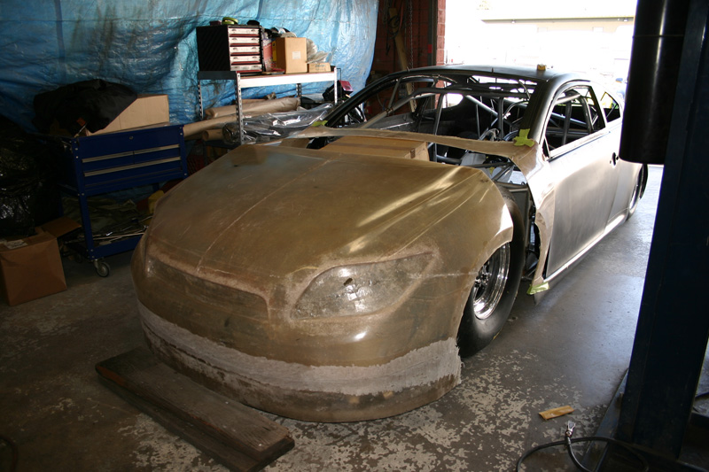

Transport

14

Auto mobile



Surfing board



Boats

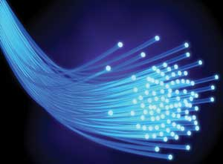

Technology

Fiber Optics

15



Background Theory

Background TheorY

16

As elaborated earlier there are many properties that can be considerably maintained in fiberglass. Following properties were tested during this project.

Physical Properties

1. Length   
2. Fineness   
3. [**Crimp**](http://textilelearner.blogspot.com/2012/01/crimp-percentage-determination-of-crimp.html)   
4. Maturity   
5. Lusture   
6. Softness   
7. Resiliency   
8. Work of rupture   
9. Density   
10. Appearance   
11. Flexibility   
12. Toughness   
13. Elorgation   
  
Mechanical Properties

**1. Strength   
2. Elasticity   
3. Extensibility   
4. Rigidity**

Chemical Properties

**1. Solubility in aqueous salt**  
2. Solubility in organic salt

To check the marked properties we used several background theories. They are listed as follows.

17

Beam method to find Young’s modulus

Lee’s method for thermal conductivity

Solubility

19



Experimental Procedure

Sample Preparation

19

Fiberglass row materials were cut into layers. By changing the number of layers,5 different samples were created. Two types of chemicals were used for preparing the layers. Resin, kind of glue used to stick the layers together and catalyst, which is improving the dryness of samples. Those were mixed for a particular amount ,because amount of catalyst and resin will decide the thickness of the layers.

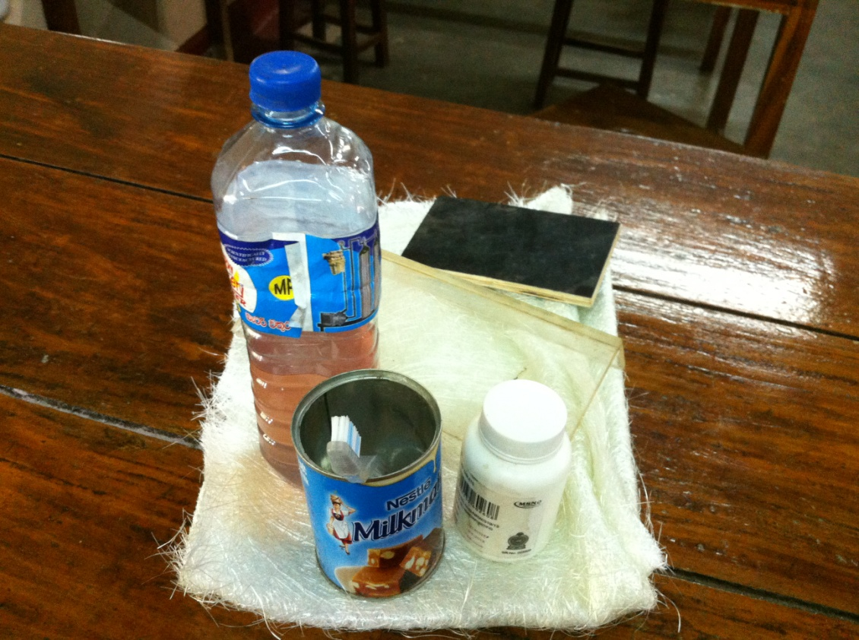

Basic row materials used

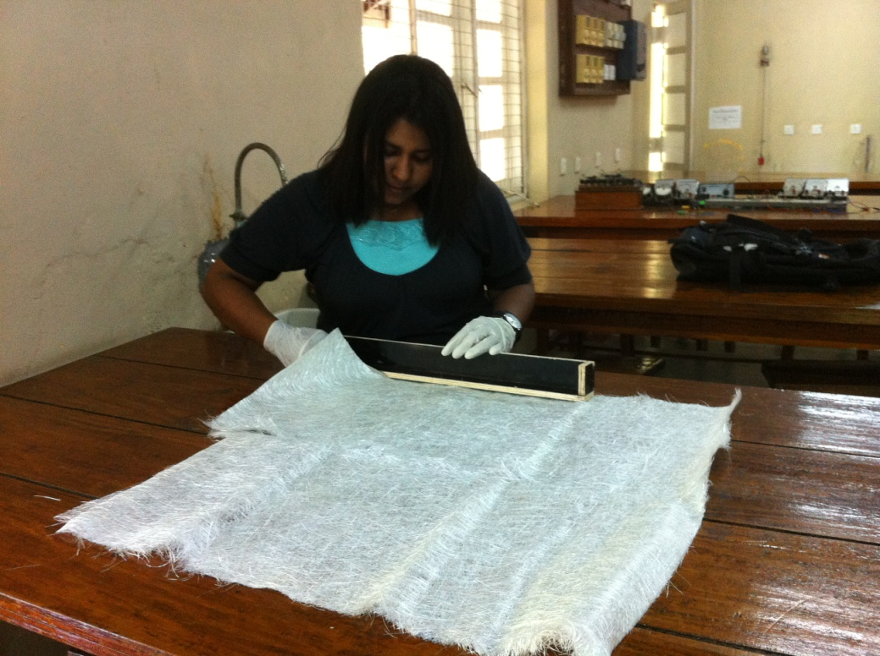

Splitting into slices

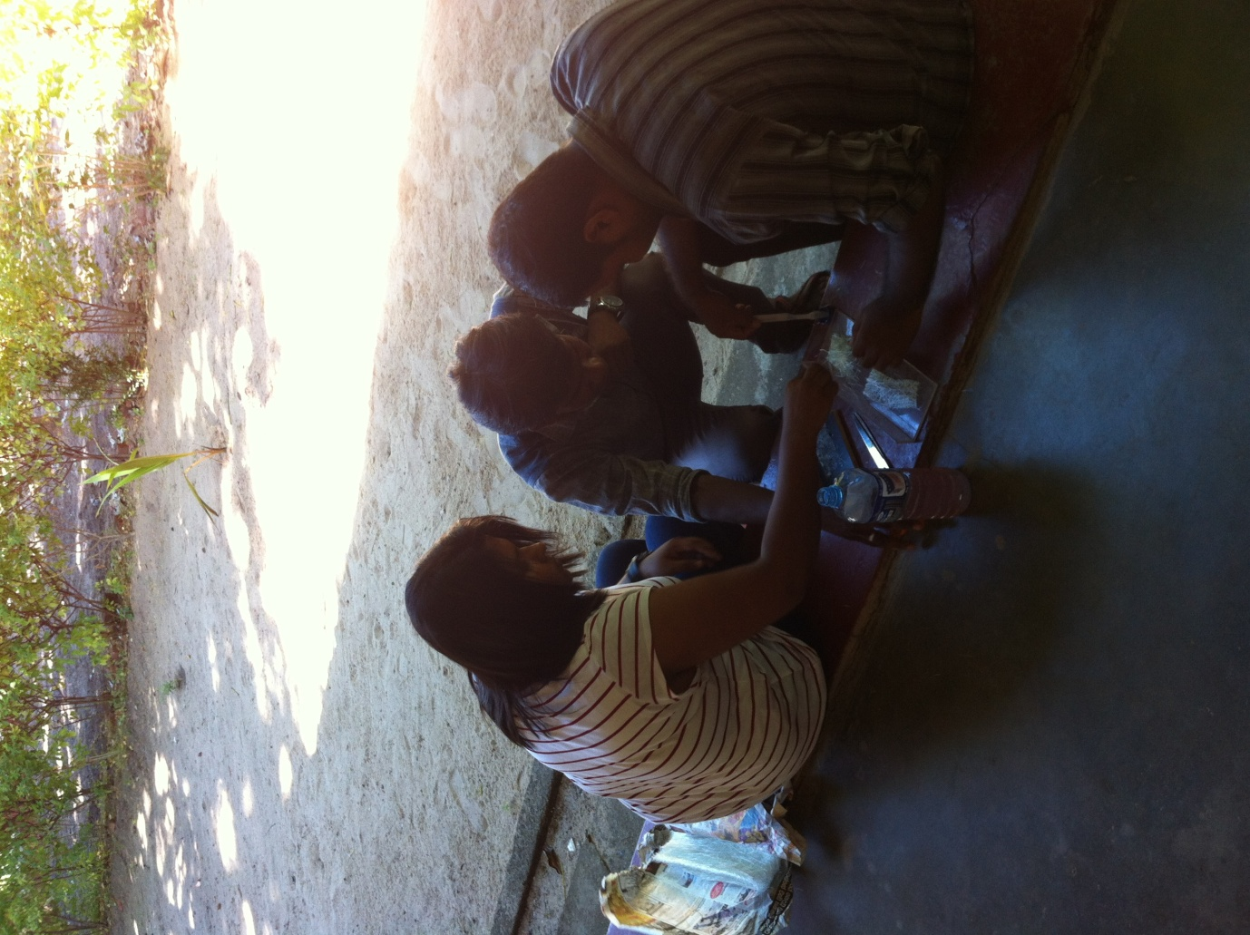Sample practical was settled up to find the best material to make a mould. Low stickiness was observed in zip board out of glass and wood.

20

Sample test

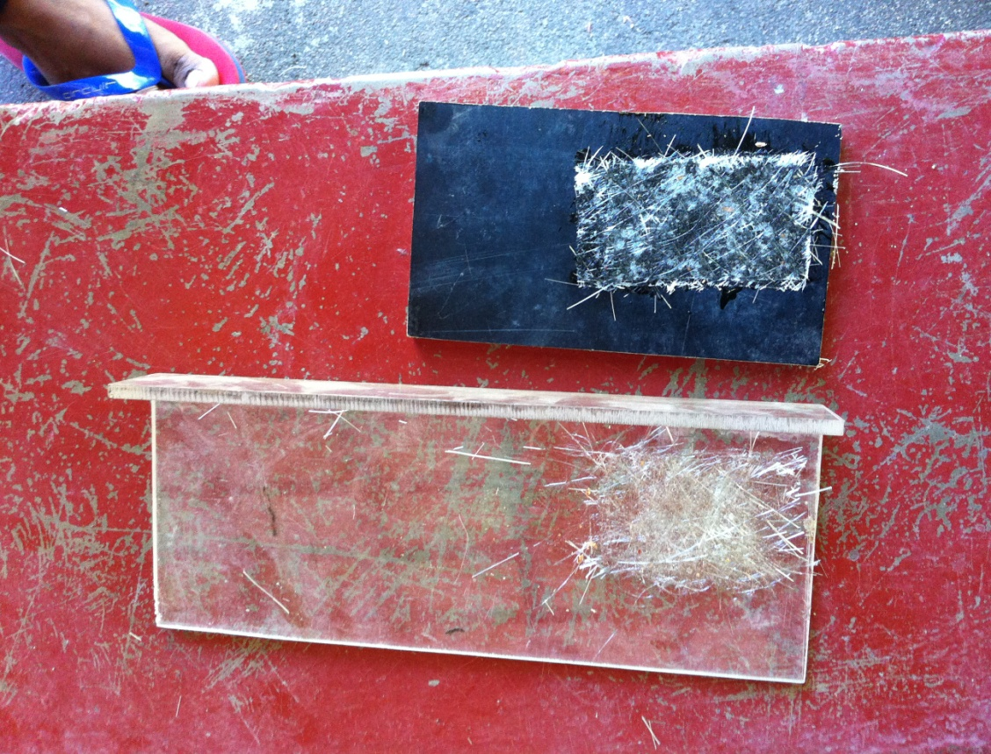

Zip board, glass

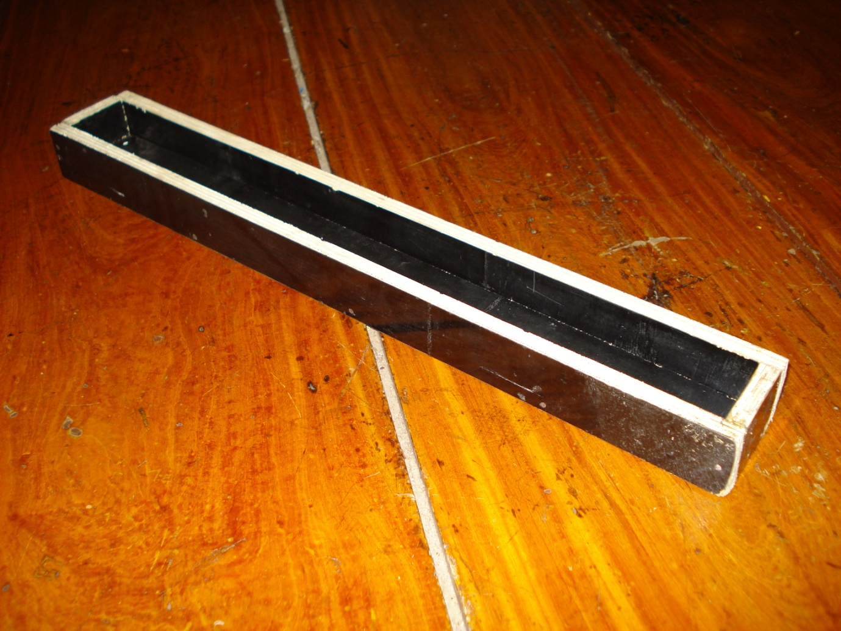A mould was designed to get identical samples. For the layer 1 only one fiberglass mat was used. Likewise all the samples were prepared up to layer 5, which was stiffer.

21

Sample Mould

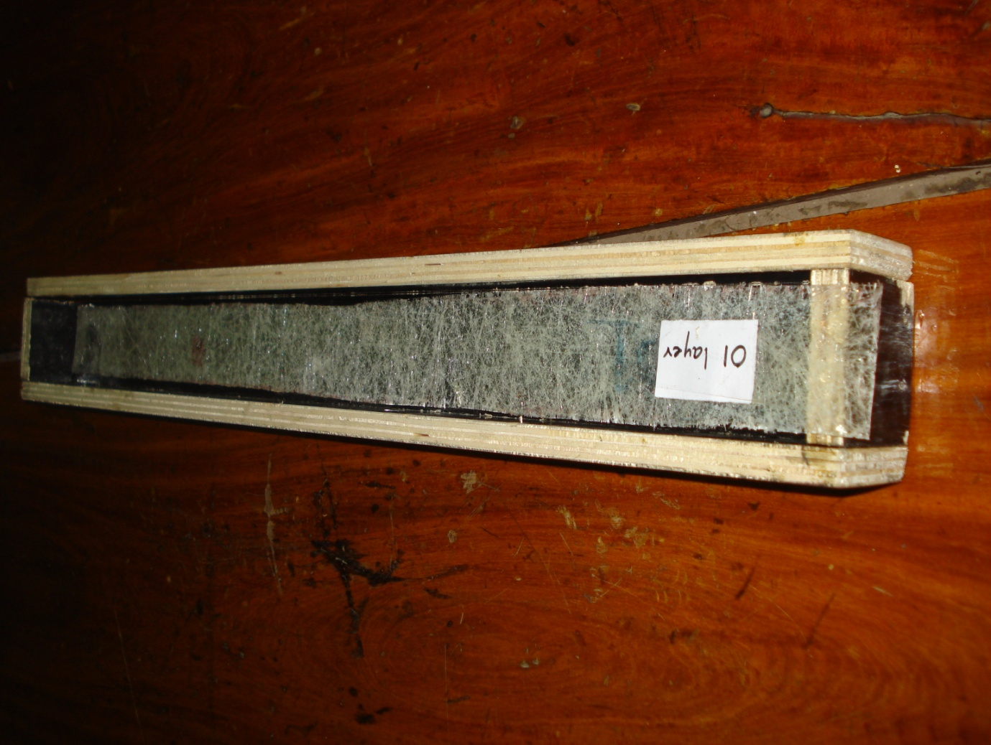

Sample Mould with a layer

Samples were dried for some time and they were removed from the mould carefully. Each layer was labeled by a number for the easiness of the identification.

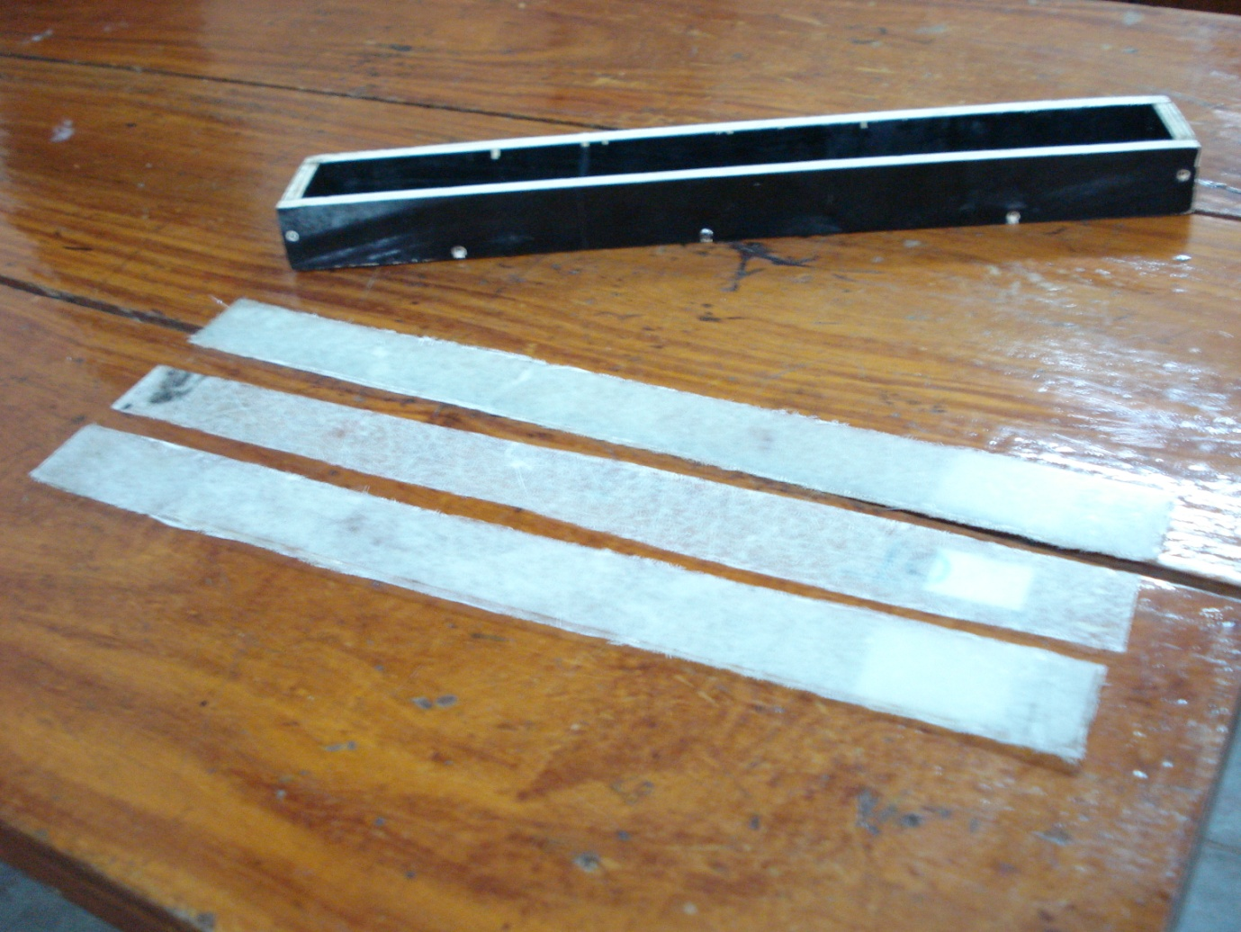

Carefully removed layers

22

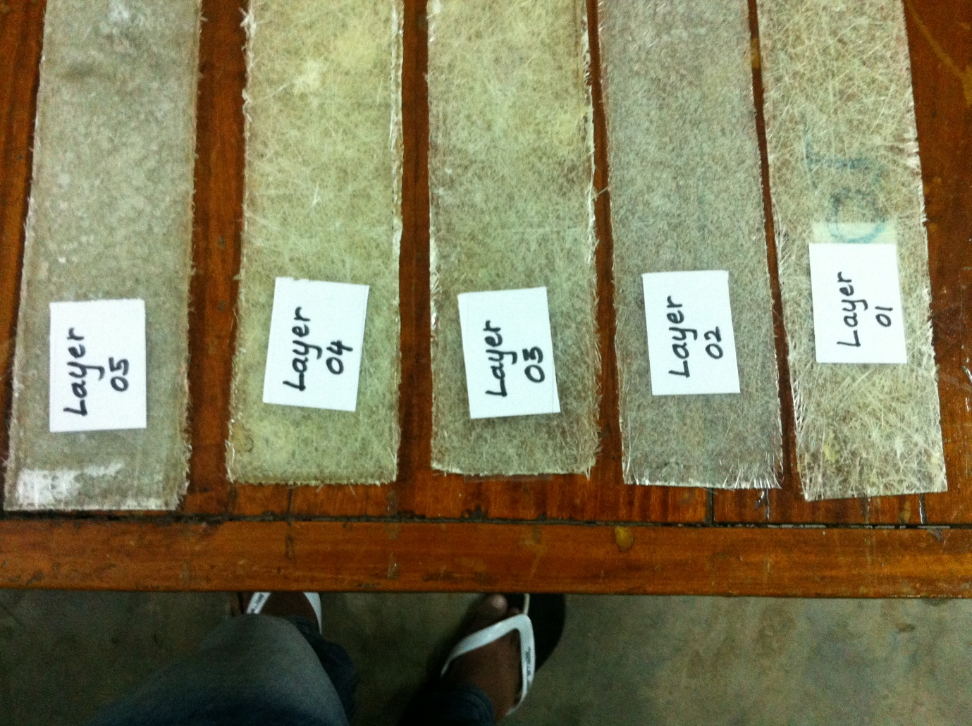

Sequentially numbered layers

Each layer’s width, length and the thickness were recorded for future aspects.

23

Length of the layers

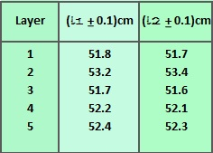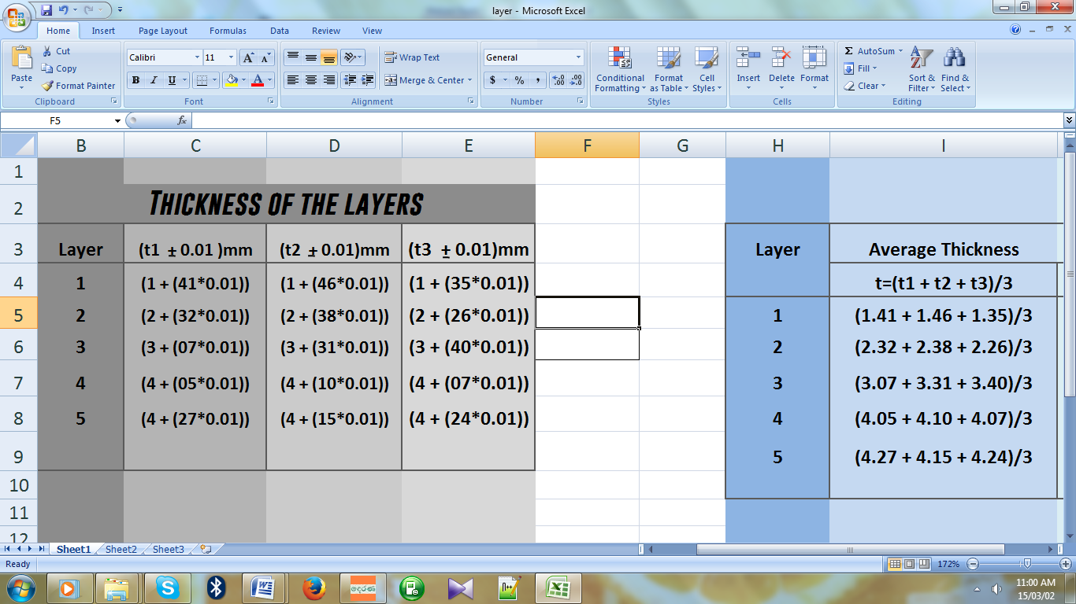

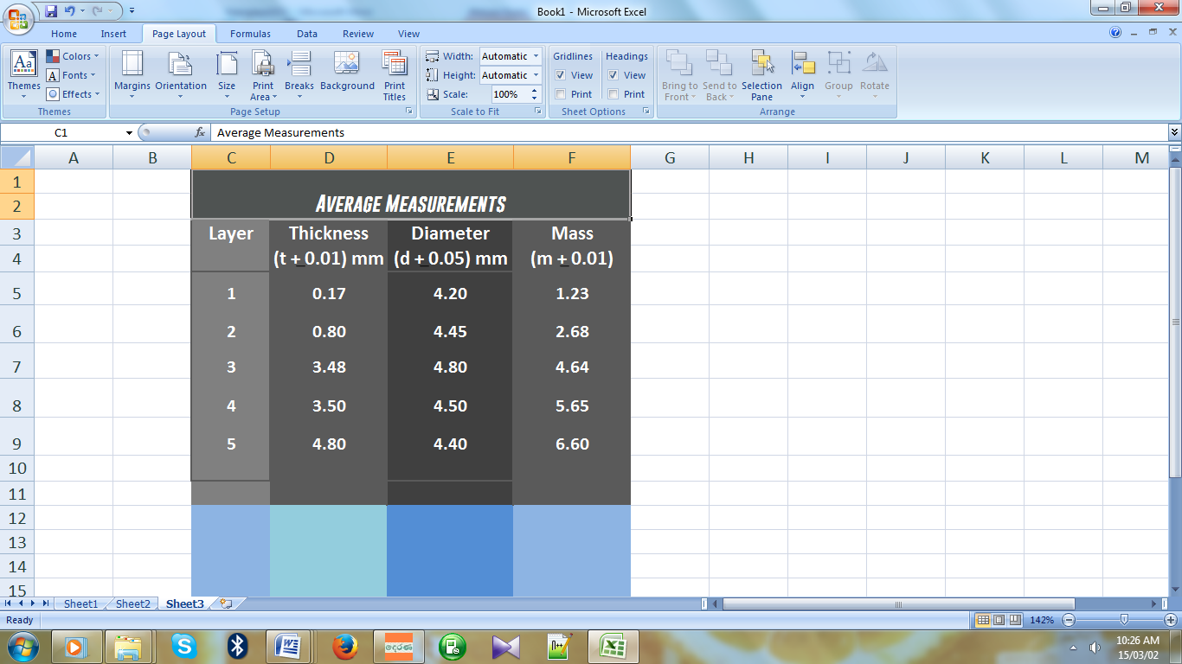

Lee’s Method

Experimental procedure for young modulus by Vibration method

24

If a cantilever of mass m0 is loaded by a mass m at its end, then the deflection y at end of the cantilever is given by

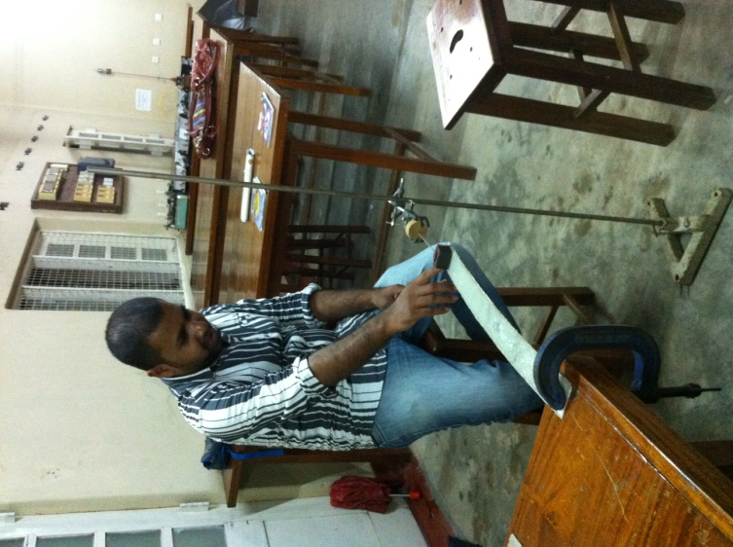 $T^{2}=\frac{16π^{2}ml^{3}}{Yab^{3}}$

Where

**l - length of the beam (cantilever)**

**b - breath of the beam**

**d - width of the beam**

Vibration Method

**Y -Young’s modulus of the beam**

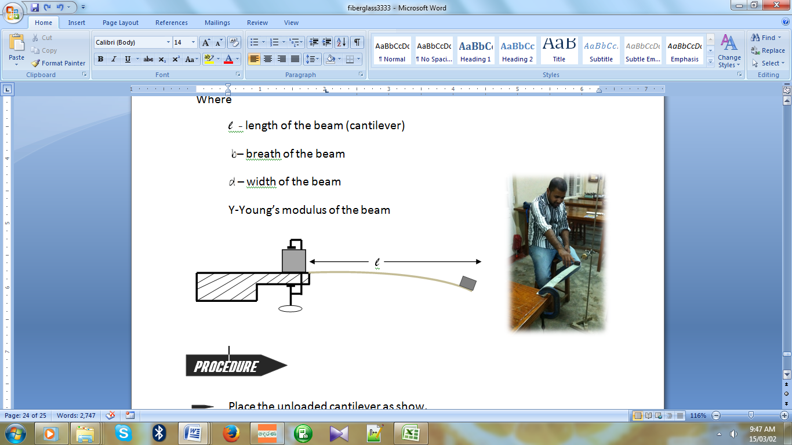

***Procedure***

Place the unloaded cantilever as show.

Attach the weight to the free end of the cantilever using a band.

Give a small vibration on the end of the cantilever.

Measure the time for 10 oscillations.

Repeat for several lengths.

Lee’s Method For Thermal Conductivity

25

## Aim

To determine the coefficient of thermal conductivity of fiberglass using Lee's disc apparatus.

## Apparatus

Lee's disc apparatus consist of a metallic disc  resting on a 5 cm deep hollow cylinder (steam chamber ) of same diameter. It has  inlet and  outlet tubes for steam. In addition, it has radial holes to insert thermometers. Thermal conductivity is the property of a material . It indicates the ability of a material to conduct heat. When steam is passed through the cylindrical vessel  a steady state is reached soon. At the steady state, heat conducted through the bad conductor is equal to  heat radiated from the Lees disc.

## Theory

The Lee’s Disc experiment determines an approximate value for the thermal conductivity k of a poor conductor like fiberglass, glass, cardboard, etc.

The procedure is to place a disc made of the poor conductor, radius r and thickness x, between a steam chamber and two good conductivity metal discs (of the same metal) and allow the setup to come to equilibrium, so that the heat lost by the lower disc to convection is the same as the heat flow through the poorly conducting disc. The upper disc temperature T2 and the lower disc temperature T1 are recorded. The poor conductor is removed and the lower metal disc is allowed to heat up to the upper disc temperature T2.

Finally, the steam chamber and upper disc are removed and replaced by a disc made of a good insulator. The metal disc is then allowed to cool through T1 < T2 and toward room temperature T0.

The temperature of the metal disc is recorded as it cools so a cooling curve can be plotted. Then the slope s1 =ΔT/Δt  of the cooling curve is measured graphically where the curve passes through temperature T1.

26

Steam Chamber

Metal Disc:T2

Metal Disc:T1

**Fiber glass**

**element**

At the steady state, rate of heat transfer (H) by conduction is given by;

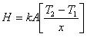

Where,

 k         - Thermal conductivity of the sample

 A         - Cross sectional area,

T2 - T1- Temperature difference across the sample.

x          - Thickness of the bad conductor

The sample is an insulator. It is in the form of a thin disc with large cross sectional area (A = πr2) compared to the area exposed at the edge (a = 2πrx) in order to reduce the energy loss. Rate of energy transfer across the sample can be increased by keeping 'x 'small and 'A 'large. Keeping x small means  the apparatus will reach a steady state quickly.

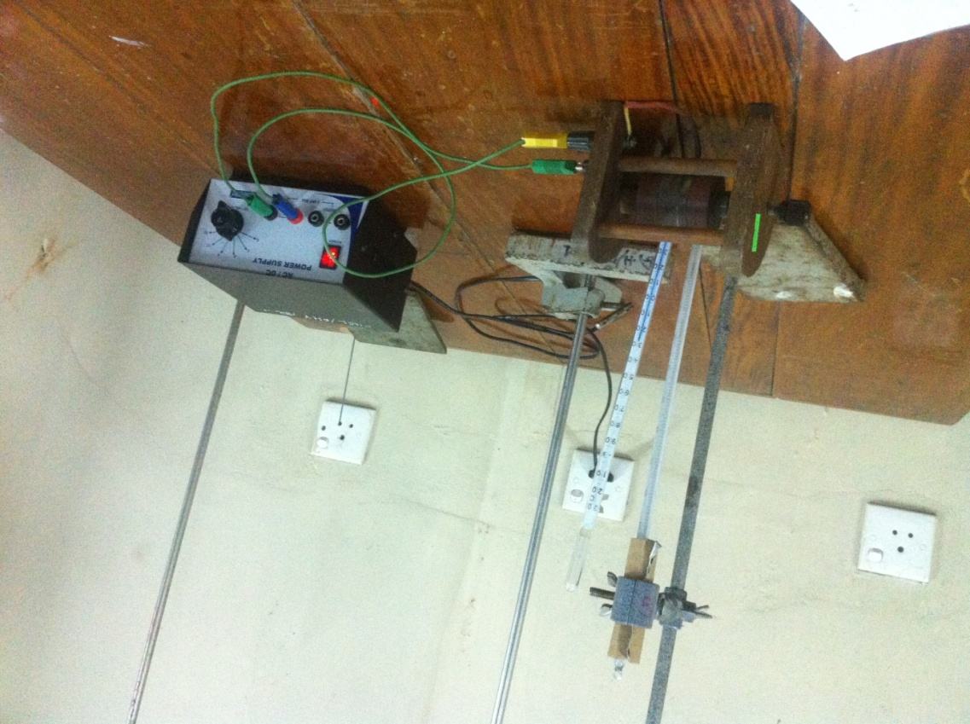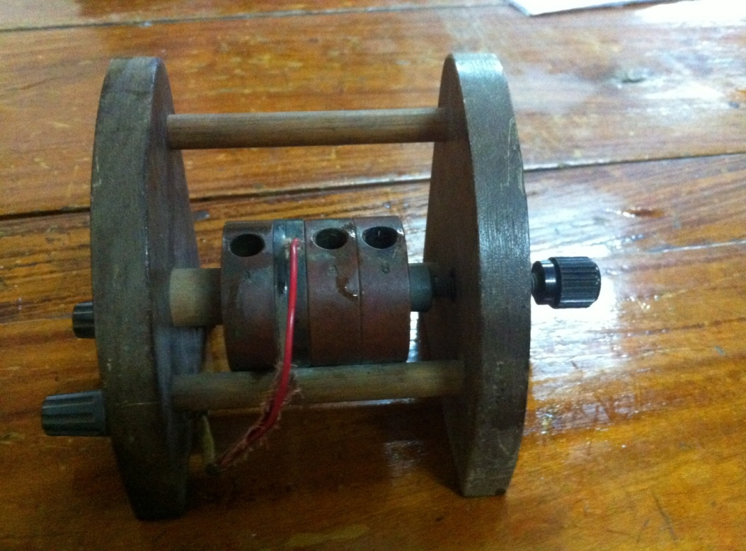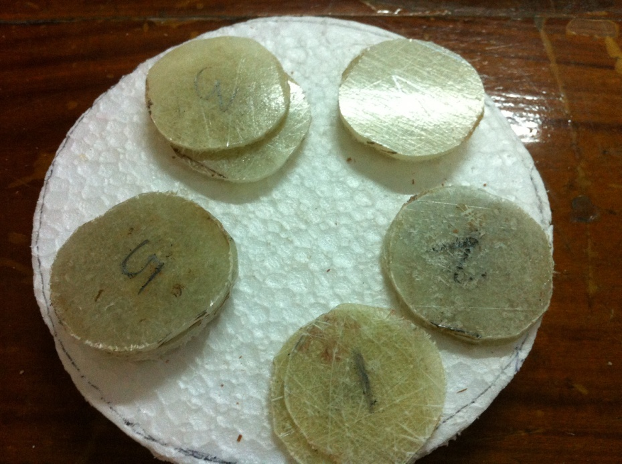

27

Practical Setup

Lee’s Apparatus

Sliced Fiberglass samples

20

Sliced Fiberglass samples

Chemical Reactions

28

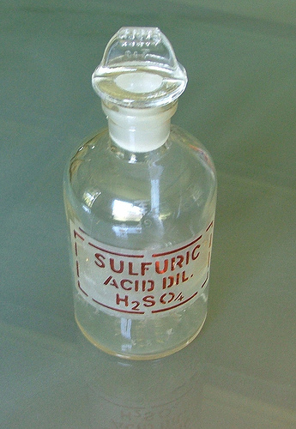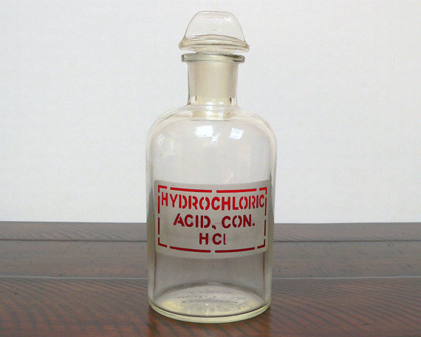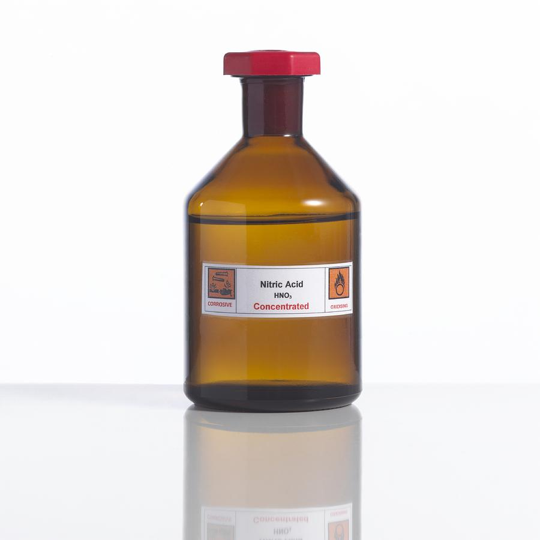Several chemicals were used to check the chemical reactions in each layer.3 samples from each layer were used each time. Fifteen minutes of time was given for the reaction. Following chemicals were used.HNO3,H2SO4,HCl.

Observations were noted down in each and every time. While some chemicals react with the fiberglass samples some didn’t show any reactions.

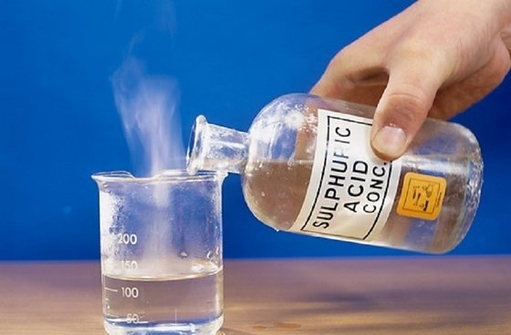

Observations

|  |  |  |  |
| --- | --- | --- | --- |
| Observations after 15 minuites    29 | | | |
| Layer # | **HNO3** | **H2SO4** | **HCl** |
|  |  |  |  |
| 01 | Bubbles appeared | Bubbles appeared | Bubbles appeared |
|  | Color of sample changed to light yellow | Color of sample changed to dark brown | Gas came out |
|  |  |  |  |
| 02 | Bubbles appeared | Bubbles appeared | Bubbles appeared |
|  | Color of sample changed to light yellow | Color of sample changed to dark brown soon | No color changed could be observed |
|  |  |  |  |
| 03 | No bubbles appeared | Color of sample changed to dark brown | Bubbles appeared |
|  | No reaction observed | Color of chemical changed to light brown | No reaction observed |
|  |  |  |  |
| 04 | No bubbles appeared | Color of sample changed to light brown | Bubbles appeared |
|  | No reaction observed |  | No reaction observed |
|  |  |  |  |
| 05 | No bubbles appeared | No bubbles appeared | No bubbles appeared |
|  | No reaction observed | No reaction observed | No reaction observed |
|  |  |  |  |

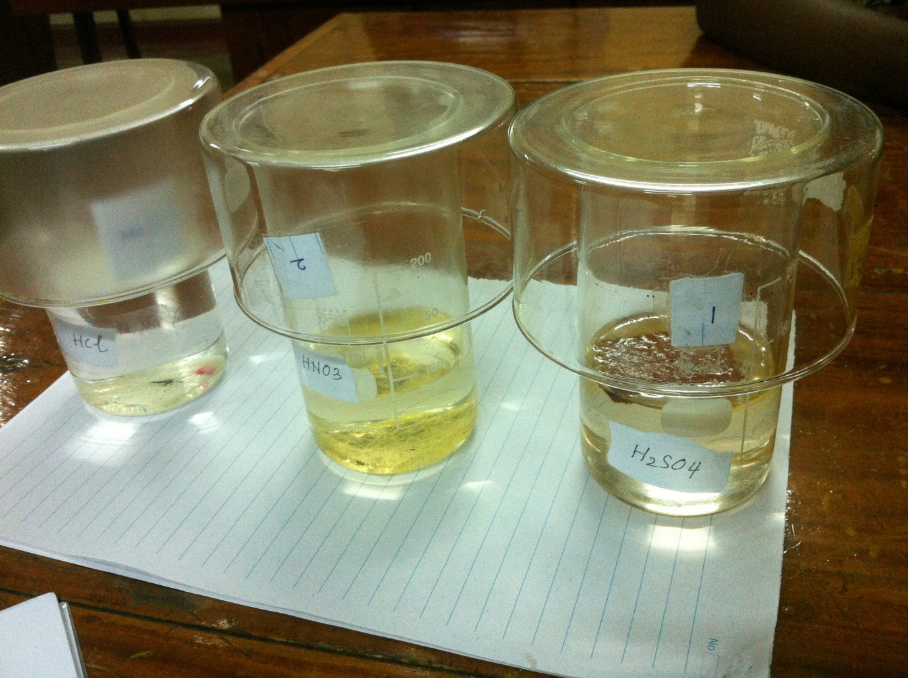Chemical Reactions Layer 1

30

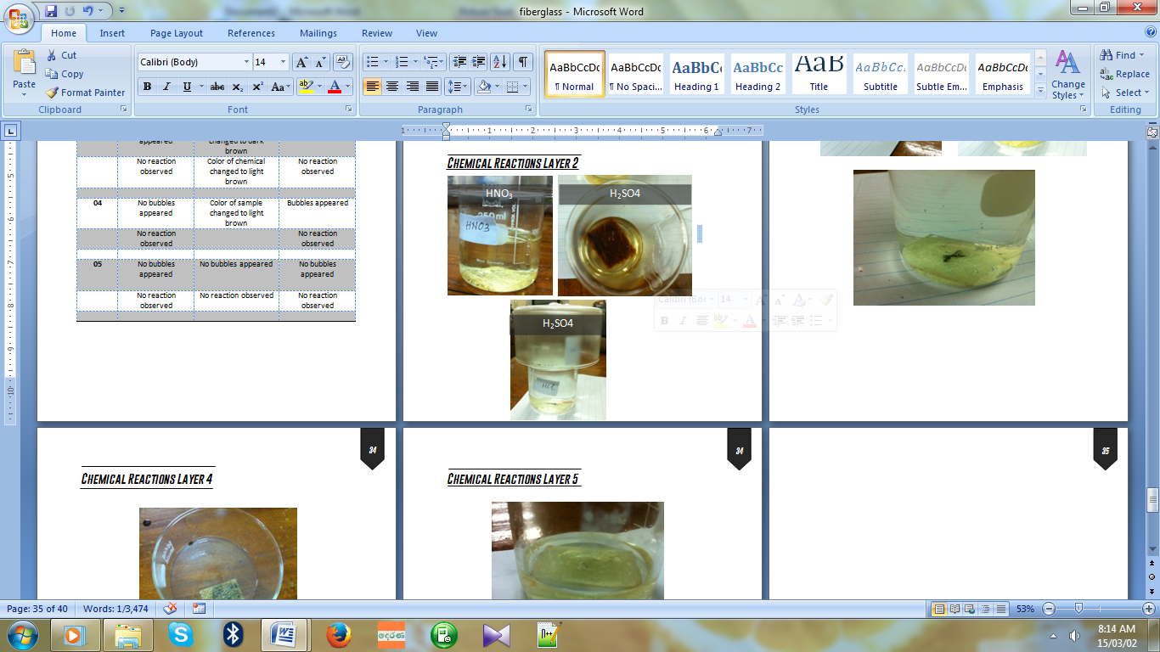

Layer 1 was reacted with all chemicals easily

H2SO4

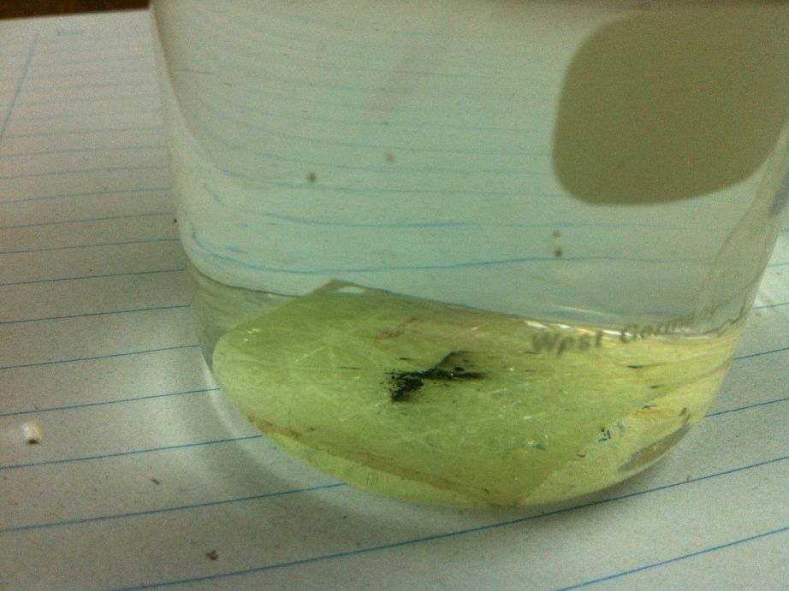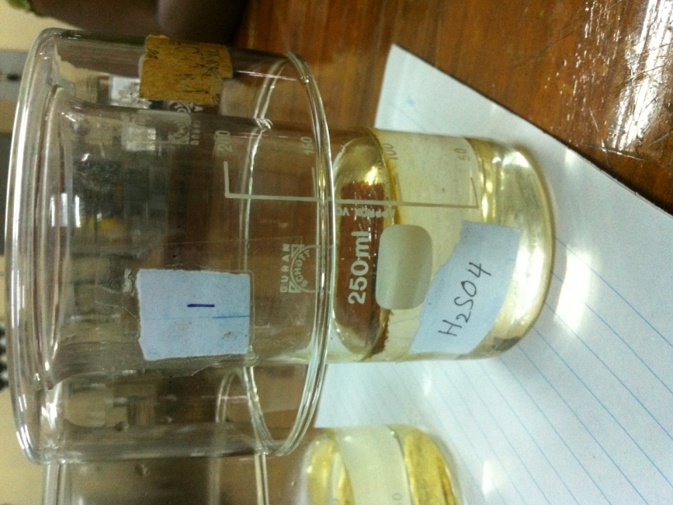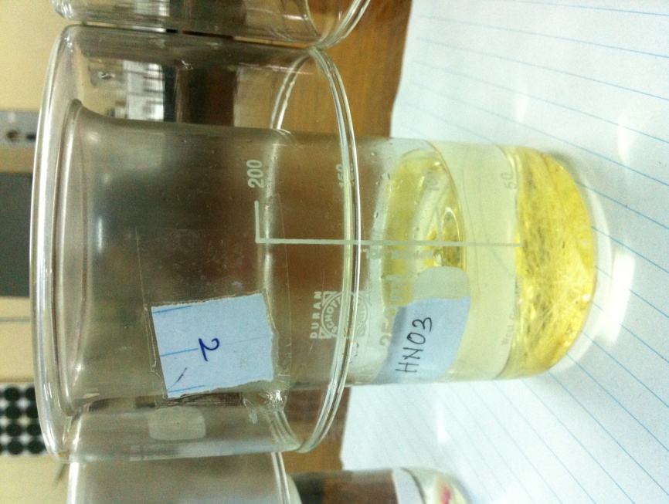Chemical Reaction Layer 3Chemical Reactions Layer 4

31

32

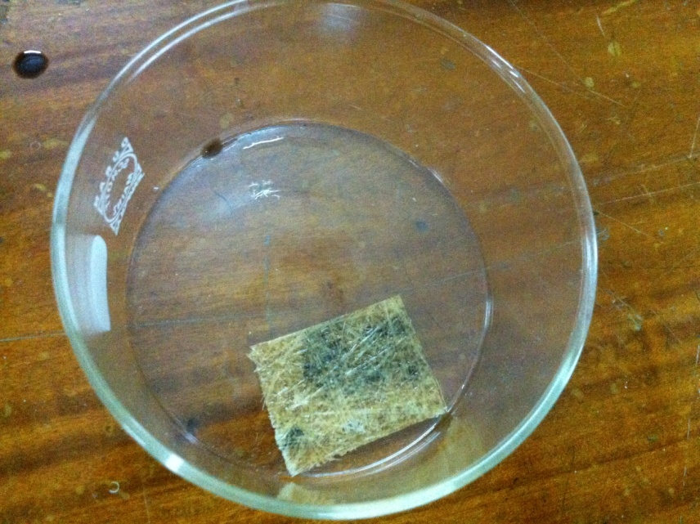

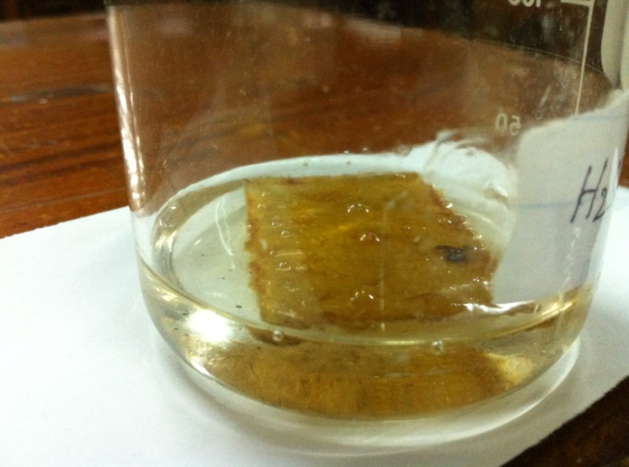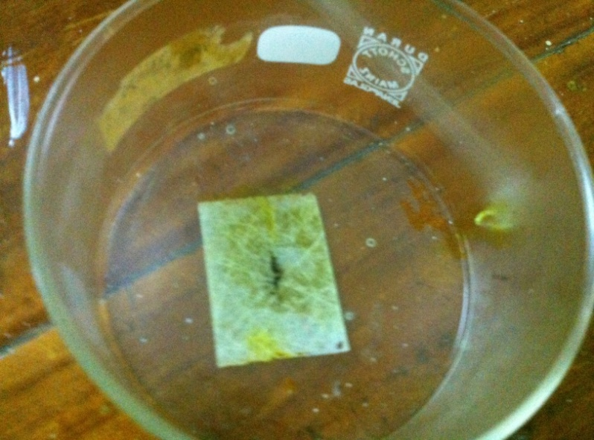

Chemical Reactions Layer 5

33

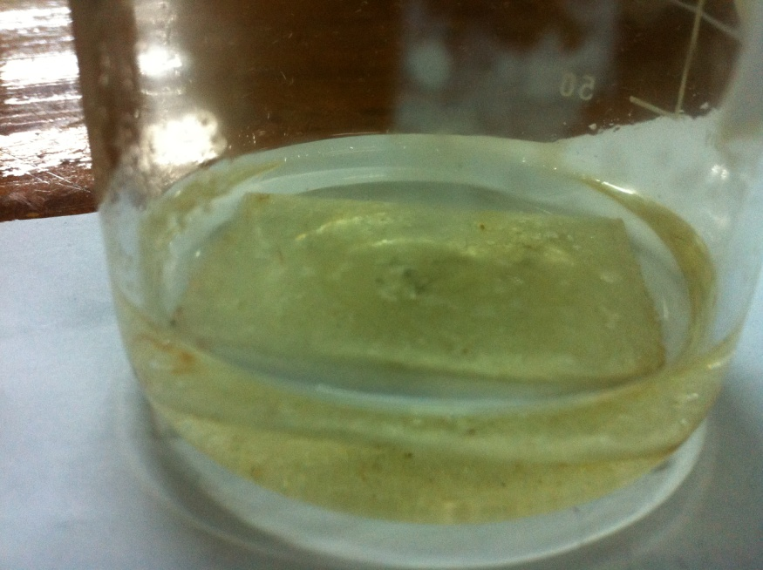

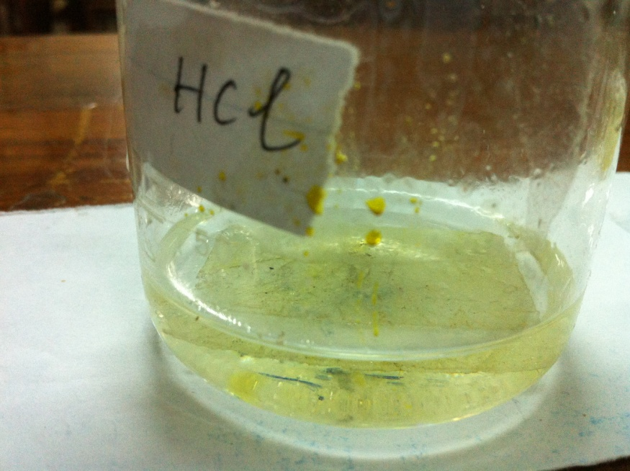

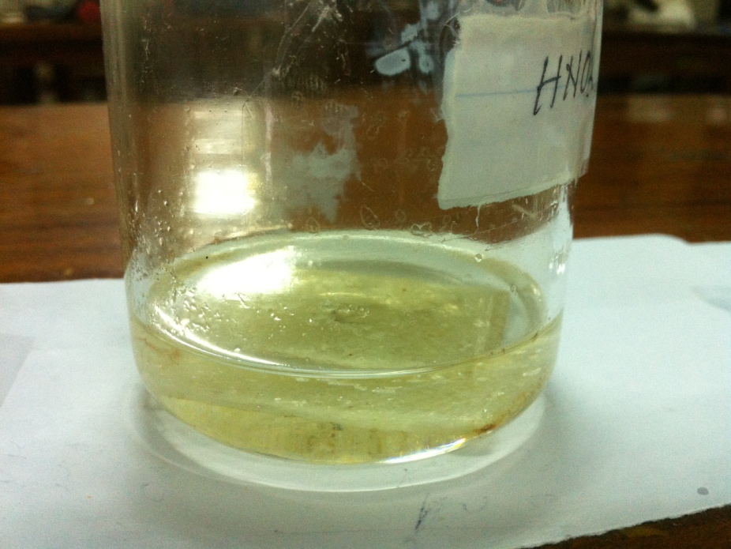

34

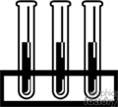

Results & calculations

Young Modulus

35

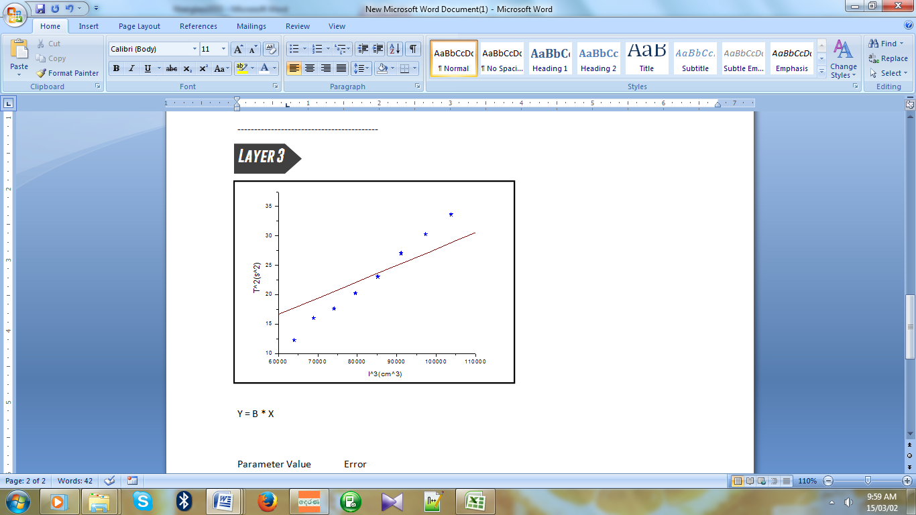

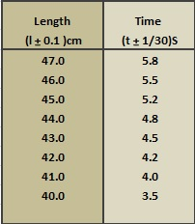

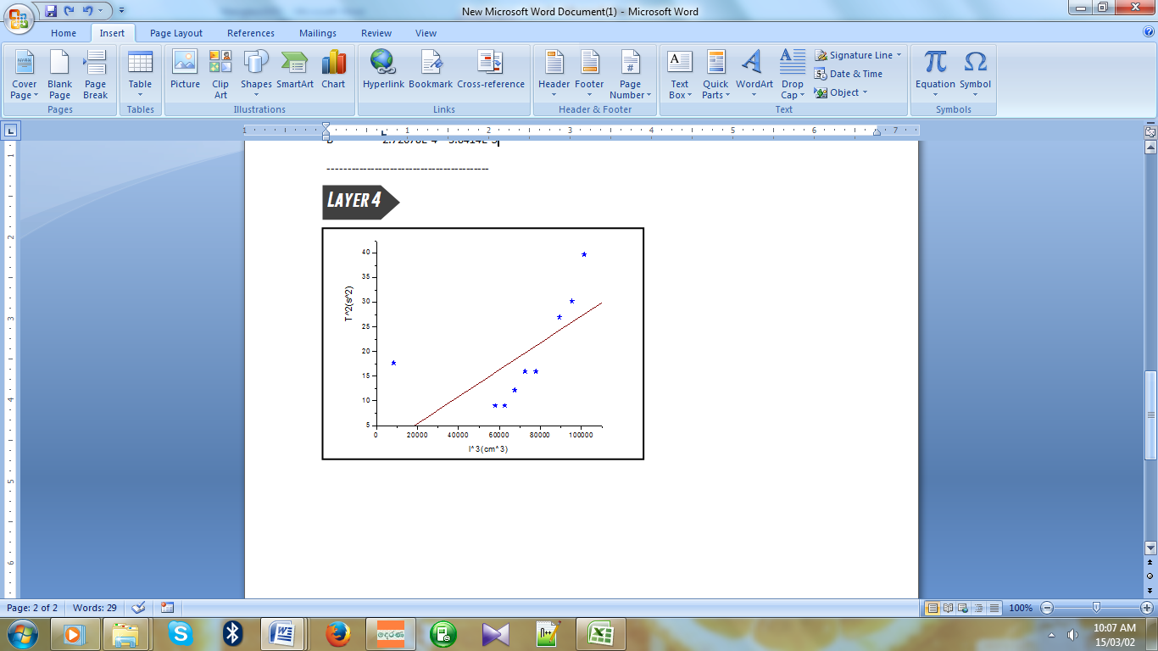

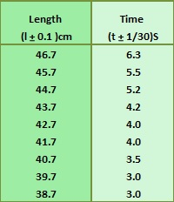

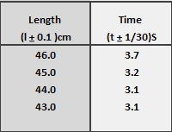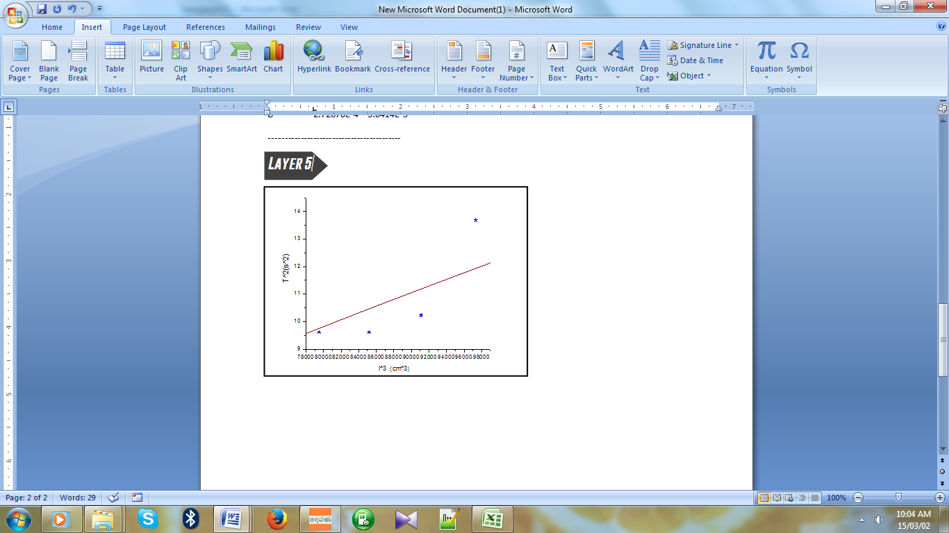

36

Using the “Origin” graph plotting software the graphs were drawn. It’s impossible to take measurements for the thicker layers as the number of countable vibrations were low.

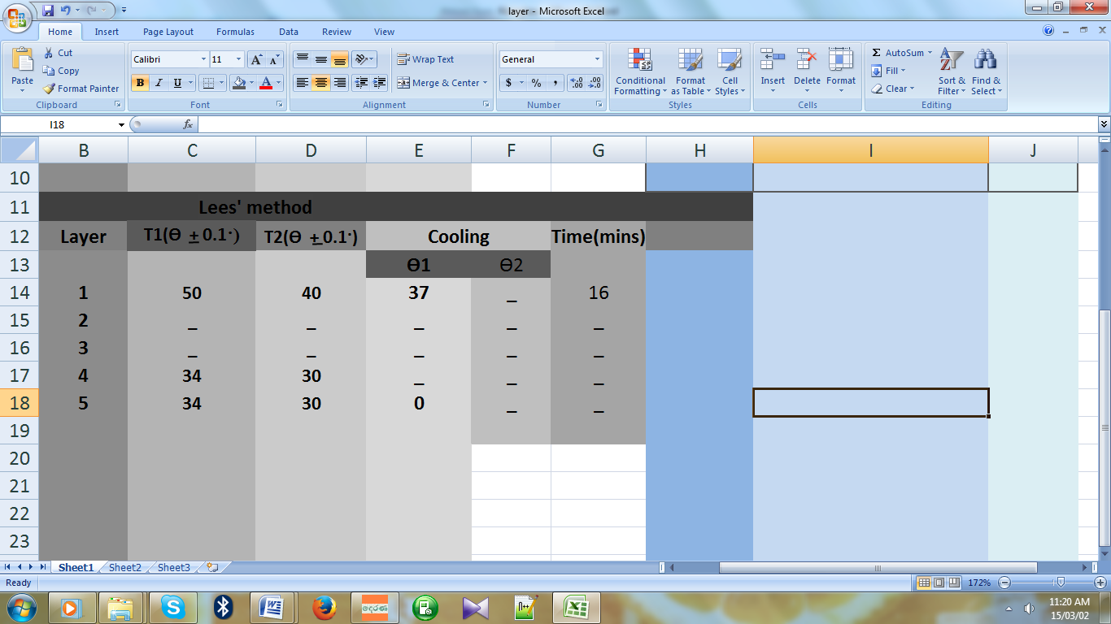Lees Method for Calculating Thermal Conductivity

37

38



Discussion & conclusion

[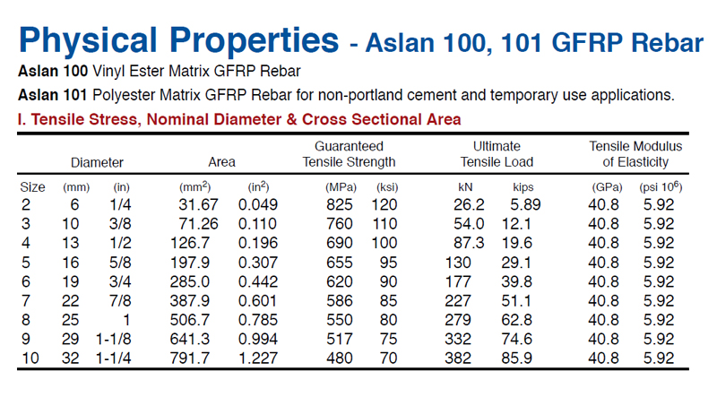](http://www.d4architects.com/images/fiberbar_physicalpro.jpg)

37

True values of fiberglass samples are mentioned above. Moreover those values can be varied due to resin and catalyst used. Thickness of the layer used also dependable.

38



Future Aspects

39

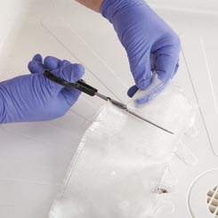Fiberglass is all purpose material which can be used for many aspects. It can cover up many industries such as Architecture, construction,Medical,cutical and etc.Fiberglass can be mostly used for repairing automobile bodyparts.

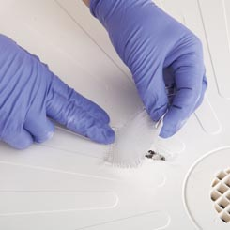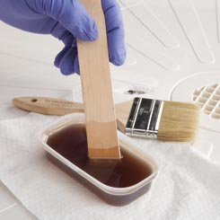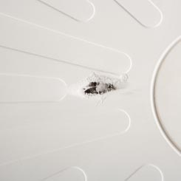

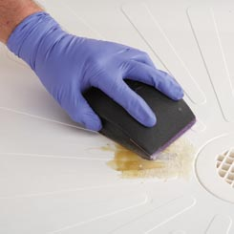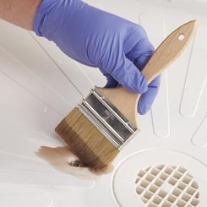

40

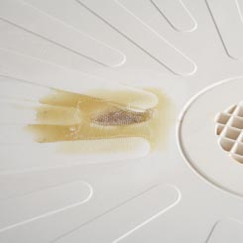

It’s cheap able to use fiberglass for repairing, mending instead of another alternatives

Reference

40

<http://textilelearner.blogspot.com/2012/02/properties-of-fiber-properties-of.html#ixzz3T1YGk4Em>

<http://www.fiberglass-world.com/galeria.html>

http://www.worldinaspin.com/articles/characteristics

<http://www.diy-fiberglass-repair.com/Fiberglass-repair-kit.html>

<http://www.sceadu.com/support_fiberglass.html>

<http://www.afterhoursautomotive.com/sciontc.html>

<http://www.madehow.com/Volume-2/Fiberglass.html>

<http://www.octanemotorsports.com/blog/what-is-fiberglass-why-is-fiber-glass-used-to-make-custom-car-parts-like-body-kits-or-hoods/>

<http://www.pleatedcartridges.com/properties_fiber.html>

http://www.engineeringtoolbox.com/thermal-conductivity-d_429.html